Assignment 5&6
Name: Digvijay Sawant
PRN: 260240125023

1. Write a script to calculate factorial of a number using while loop.
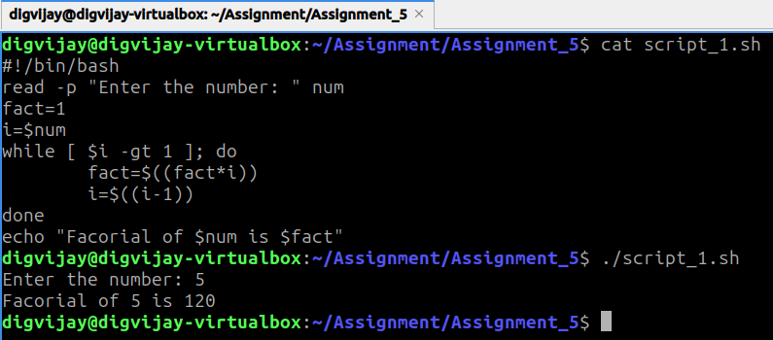
2. Write a script to display first 20 even numbers using for loop.
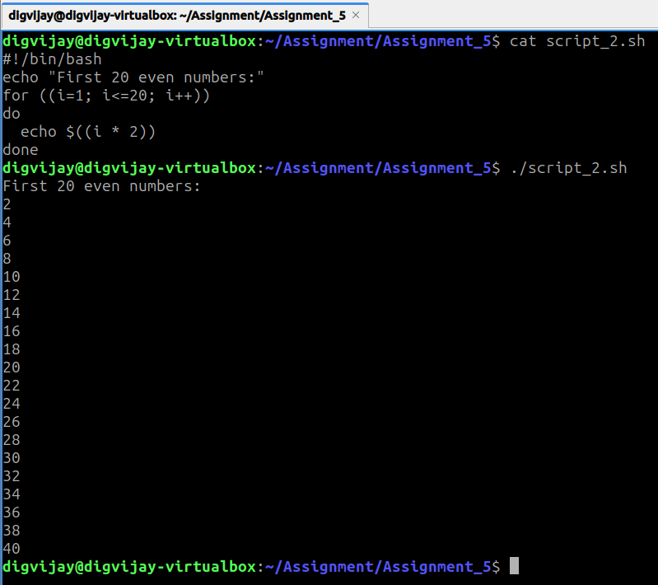

3. Write a script to print the multiplication table of a number given by the user.
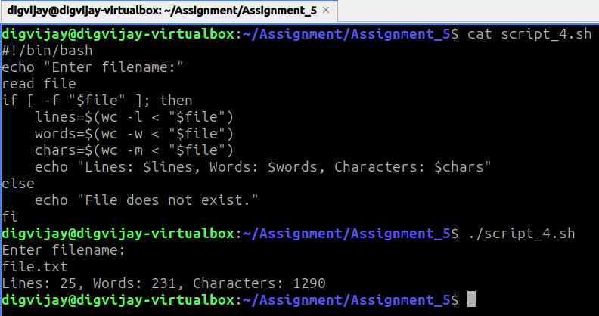

4. Write a script to count lines, words, and characters in a file.
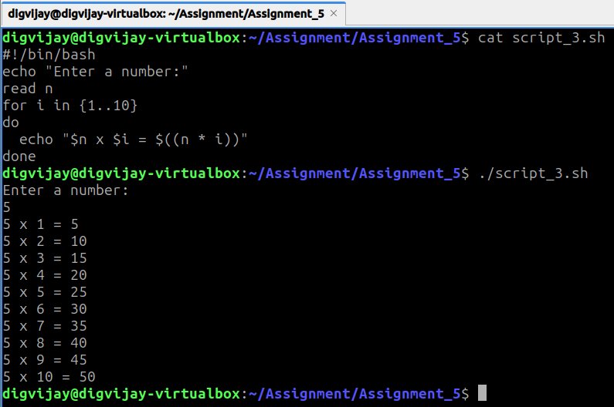

5. Write a script to display a menu (date, calendar, list files, exit) and execute the chosen option.
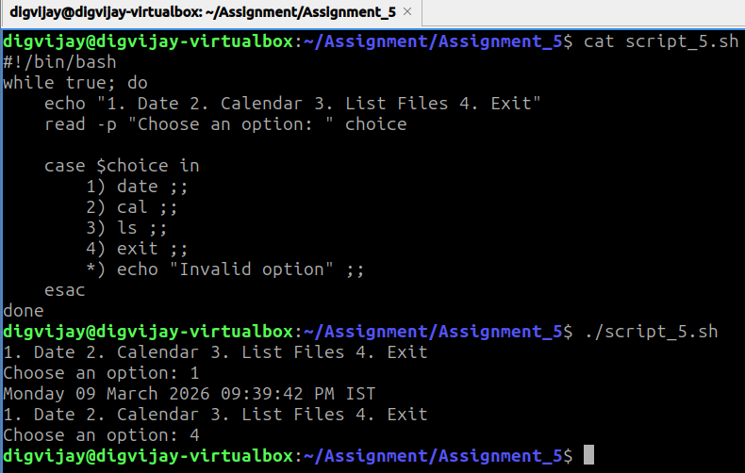

(Linux Shell Programming continued)

1. Write a shell script that accepts a filename as an argument and displays whether it is a directory, a regular file, or something else.
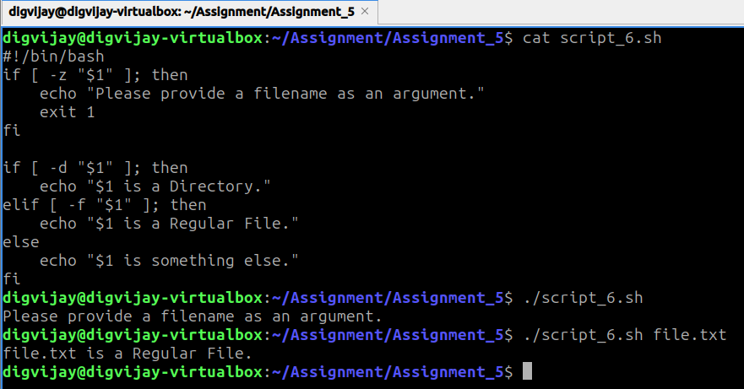

2. Write a script that reads a number and prints whether it is positive, negative, or zero.
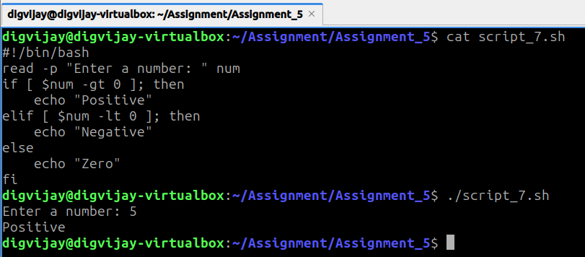

3. Write a script that accepts a username and checks whether the user is currently logged in.
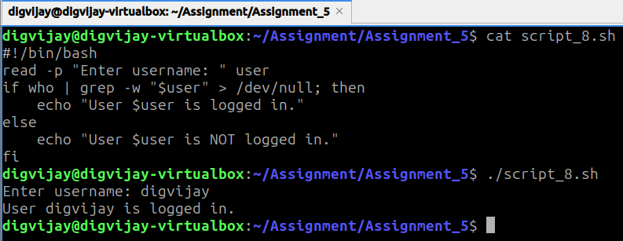

4. Write a script that prints the first 10 natural numbers using until loop.
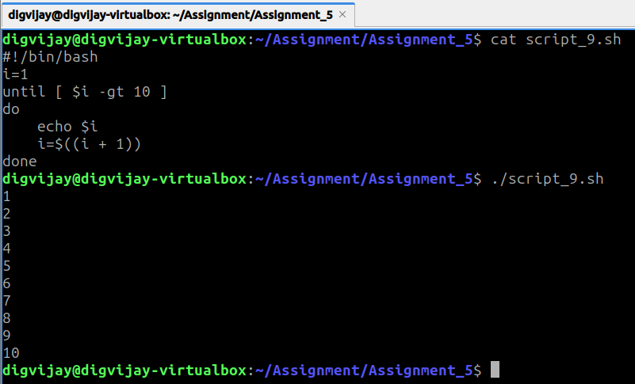

5. Write a script that demonstrates use of functions by creating one for addition and one for subtraction.
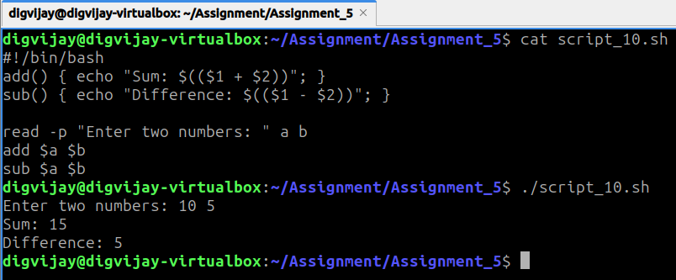

(Git / GitHub)

1. Install Git and configure username and email.
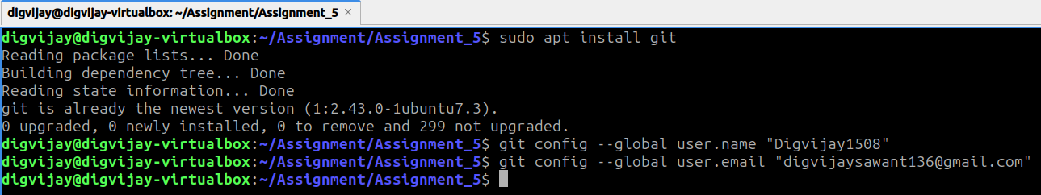

2. Create a local repository, add a file, and commit changes.
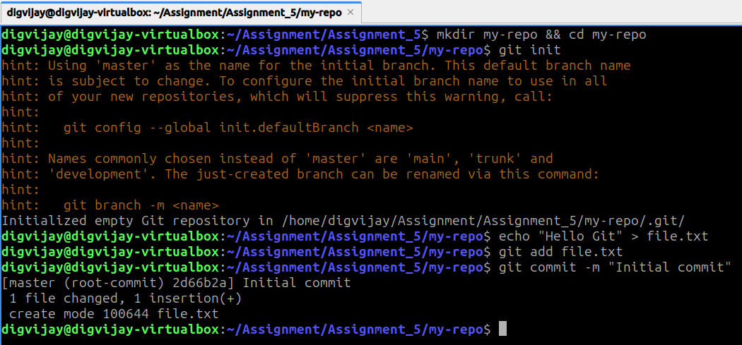

3. Create a new branch, switch to it, make changes, and merge it with main.
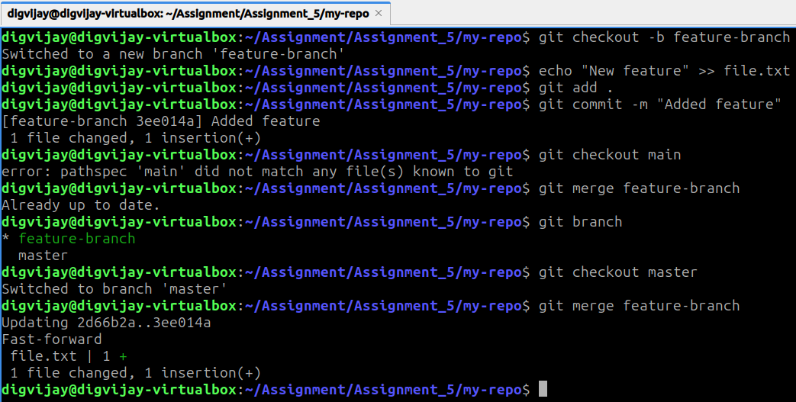

4. Push the local repository to GitHub using command line.
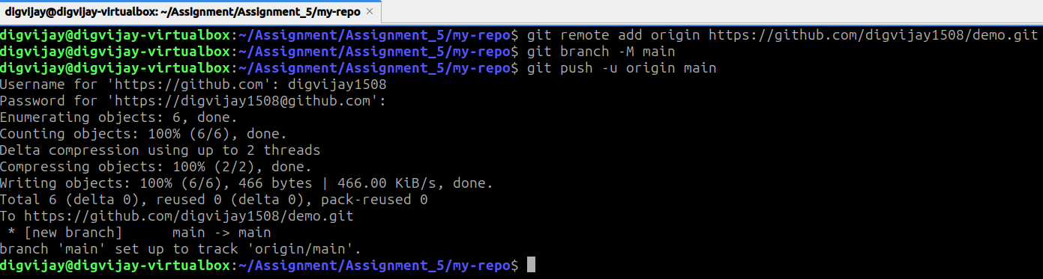

5. Clone a repository from GitHub, edit files, and push changes back.
